**Converting a Page to a PDF File**

You can render any page as a PDF by adding the renderAs attribute to the <apex:page> component, and specifying “pdf” as the rendering service. For example:

|  |  |
| --- | --- |
| 1 | <apex:page renderAs="pdf"> |

Visualforce pages rendered as PDFs will either display in the browser or download as a PDF file, depending on your browser settings.

In the previous tutorial, you used a Visualforce page to change the name of a company. Suppose you wanted to generate an announcement of the new name as a PDF. The following example produces such a page, along with the current date and time.

|  |  |  |
| --- | --- | --- |
| 01 | <apex:page standardController="Account" renderAs="pdf" applyBodyTag="false"> | |
| 02 | <head> |

|  |  |
| --- | --- |
| 03 | <style> |
| 04 | body { font-family: 'Arial Unicode MS'; } | |

|  |  |  |
| --- | --- | --- |
| 05 | .companyName { font: bold 30px; color: red; } | |
| 06 | </style> |

|  |  |  |
| --- | --- | --- |
| 07 | </head> | |
| 08 | <body> |

|  |  |
| --- | --- |
| 09 | <center> |
| 10 | <h1>New Account Name!</h1> | |

|  |  |
| --- | --- |
| 11 |  |
| 12 | <apex:panelGrid columns="1" width="100%"> | |

|  |  |  |
| --- | --- | --- |
| 13 | <apex:outputText value="{!account.Name}" styleClass="companyName"/> | |
| 14 | <apex:outputText value="{!NOW()}"></apex:outputText> |

|  |  |  |
| --- | --- | --- |
| 15 | </apex:panelGrid> | |
| 16 | </center> |

|  |  |
| --- | --- |
| 17 | </body> |
| 18 | </apex:page> | |

Things to note about the page:

* <style> is CSS markup, not Visualforce markup. It defines the font family used for the entire page, as well as a particular style for the company name.
* Some of the output text is contained in an <apex:panelGrid> component. A panel grid renders as an HTML table. Each component found in the body of the <apex:panelGrid> component is placed into a corresponding cell in the first row until the number of columns is reached. As there is only a single cell, each output text is displayed in a separate row.

**A Visualforce Page Rendered as PDF**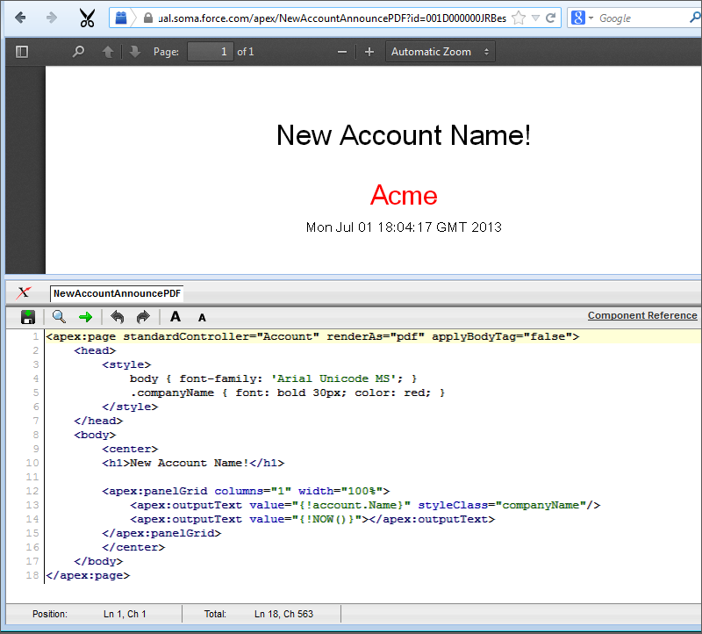

Always verify the format of your rendered page before deploying it.